|  |  |  |  |
| --- | --- | --- | --- |
| \\lyng-dc1\StaffShared\Learning Bugs Animals ALL subjects\characters bugs animals\Cyril the Snail - History.jpeg**Lyng Primary School Knowledge Organiser** | | | |
| **History Topic: Egypt** | **How did beliefs influence life in Ancient Egypt?** | Year 3  *Battles, Beliefs and Buildings* | Autumn 2 |

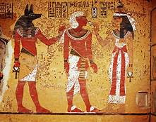

**Background information for parents and teachers**

Ancient Egypt was one of the greatest and most powerful civilizations in the history of the world. It lasted for over 3000 years from 3150 BC to 30 BC. The civilization of Ancient Egypt was located along the Nile River in northeast Africa. ... The Nile provided food, soil, water, and transportation for the Egyptians.

|  |  |
| --- | --- |
| **What Step On and Goldilocks words will I use?** | |
| **Spelling** | **Definition** |
| **afterlife** | The place where the Ancient Egyptians believed they would **go after they die.** |
| **Canopic jar** | One of four **containers** with tops in the form of animal heads of the gods, for **holding the entrails of a mummy.** |
| **chronology** | The chronology of a series of past events in the **order in which they happened.** |
| **concurrence** | When events are **occurring at the same time.** |
| **Egyptologist** | An **archaeologist** who **specializes in Ancient Egypt** |
| **hieroglyphics** | Hieroglyphics are **symbols** in the form of pictures which are used in some **writing systems**. |
| **mummy** | A **dead body** that has been specially **preserved** using embalming so that it won't rot. |
| **pharaoh** | The **supreme ruler of all of Ancient Egypt**. He or she was considered a god. |
| **pyramid** | A **giant tomb built for the pharaohs**, it was made from stone and had four sides that came to a point. |
| **sarcophagus** | A **sarcophagus i**s a **large decorative container** in which a dead body was placed in ancient times. |
| **Sphinx** | A **mythological beast** with **the body of a lion and head of a pharaoh**, they guarded tombs. |
| **tomb** | A **grave** or other **place of burial** |
| **Tutankhamun** | A **pharaoh of Egypt** that is famous for his tomb that was discovered. The tomb was largely untouched and was full of treasure. |

|  |  |
| --- | --- |
| **When? (Timeline of key events)** | |
| 7500 BC | The first settlers arrived in the Nile Valley. |
| 3200 BC | Hieroglyphs are used to keep trade records. |
| 2640 BC | The first pyramid was built. |
| 2555 BC | The Giza pyramids are built for the kings Kufu, Kharfe and Menkaure. |
| 2520 BC | The Great Sphinx is built |
| 2200 BC | The first ploughs are attached to oxen. |
| 1539 BC | Valley of the Kings starts and pharaohs are buried with their treasure. |
| 1332 BC | The 10 year rule of Tutankhamun begins. |

**Hook**

Turning our year 3 classroom into an Ancient Egyptian Tomb.

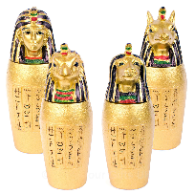

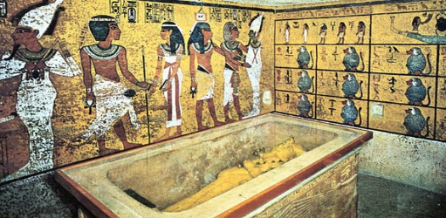

**TRIP/VISITOR**

Birmingham Museum.

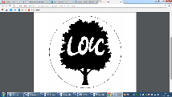

**Great Quotes**

*“From the heights of these pyramids 40 centuries look at us”*

**Focus Text**

**Our Storytelling Approach to enhance engagement**

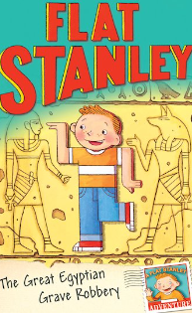

|  |  |  |
| --- | --- | --- |
| **People:**  Egyptologists | **Place:**  Valley of the Kings | **Problem:**  Discovering the Tomb of Tutankhamun |

**Key Facts and Famous Figures**

* Most Ancient Egyptian pyramids were built as tombs for pharaohs (rulers of Ancient Egypt) and their families. To date, over 130 pyramids have been discovered in Egypt.
* The pharaohs were the kings and queens of ancient Egypt. People believed the pharaoh to be half-mortal and half-god. He was believed to be the living incarnation of Horus, the sun god. Just like other royal families, the position of pharaoh was hereditary. It was usually the eldest son who became pharaoh when his father died.
* Tutankhamun reigned for roughly ten years. He died around the age of 18 and was buried in a tomb in the Valley of the Kings.
* His burial place was hidden for many centuries. The Egyptologist Howard Carter discovered it in 1922. It contained many amazing artefacts, including Tutankhamun’s famous golden death mask, a chariot and a dagger made from meteorite iron!
* The ancient Egyptians believed in 2000 Gods however, they selected 10 gods as being the most important. Ra, Amun, Horus, Thoth, Ma’at, Isis, Osiris, Hathor, Anubis and Sekhmet.

people - they placed stone circles where burials took place. Iron Age: • Tools were made from iron. Iron was heated up then the hot iron was ha of the Iron Age, coins were made and used as currency. • There were lots of battles between tribes who fought each other for more land and power.

**Diagram to be studied**

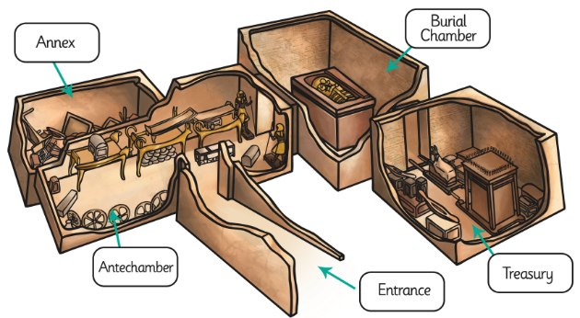

The body of the Pharaoh was placed in a sarcophagus (a large stone coffin) which was then surrounded by other chambers, filled with items that they thought they would need in the afterlife, mostly decorative items covered in gold.

**Agreed Outcome**

Non-chron report of Egyptian Gods

* What can Ancient Egyptian artefacts tell us about their beliefs?
* Why did the Ancient Egyptians build pyramids?
* How did the Ancient Egyptians communicate?
* What were the key events of Ancient Egypt?
* Why were the pharaohs so important?
* Who was Tutankhamun?

**Enquiry Quesitions:**

|  |  |  |  |
| --- | --- | --- | --- |
| \\lyng-dc1\StaffShared\Learning Bugs Animals ALL subjects\characters bugs animals\Cyril the Snail - History.jpeg**Lyng Primary School Knowledge Quiz** | | | |
| **History Topic:** | **Ancient Egyptians** | Year 3  *Battles, Beliefs and Buildings* | Autumn 2 |

|  |
| --- |
| 6. Name a part of an Egyptian tomb. |
| **S = E =** |

|  |  |  |
| --- | --- | --- |
| 7. What was the name of the Egyptian pharaoh who ruled from the age of 9? | **S** | **E** |
| a) King Tut |  |  |
| b) King Hut |  |  |
| c) King Mut |  |  |

|  |  |
| --- | --- |
| 8. What was the Egyptian writing system called? | |
| **S = E =** |

|  |  |  |
| --- | --- | --- |
| 9. A sarcophagus is… | **S** | **E** |
| a stone coffin |  |  |
| an Egyptian disease |  |  |
| an Egyptian pharaoh |  |  |

|  |  |  |
| --- | --- | --- |
| 10. Why did the Egyptians build pyramids? | **S** | **E** |
| To protect the tombs. |  |  |
| To play in. |  |  |
| To eat in. |  |  |

**Ancient Egyptian Quiz**

|  |  |  |
| --- | --- | --- |
| 1. What is the name of the river that runs through Egypt? | **S** | **E** |
| 1. Severn |  |  |
| 1. Nile |  |  |
| 1. Thames |  |  |

**Start :**

**End :**

|  |  |  |
| --- | --- | --- |
| 2. What is the definition of a Pharaoh? | **S** | **E** |
| a) A builder who created the pyramids |  |  |
| b) The supreme ruler. They were considered a god. |  |  |
| c) A famous actor. |  |  |

|  |  |  |
| --- | --- | --- |
| 3. Where did Ancient Egyptians think people went after death? | **S** | **E** |
| a) Heaven |  |  |
| b) Afterlife |  |  |
| c) Down the Nile |  |  |

|  |  |  |
| --- | --- | --- |
| 4. An archaeologist who specialises in Ancient Egypt is called… | **S** | **E** |
| a) Egyptologist |  |  |
| b) Settler |  |  |
| c) Invader |  |  |

|  |  |  |
| --- | --- | --- |
| 5. Which one of these was used in the Egyptian number system? | **S** | **E** |
| 1. A chariot |  |  |
| 1. A frog |  |  |
| 1. A pyramid |  |  |